L-00

Instruction on preparing an abstract
for the 11th KSUPS conference

X.Y. Presenting Author¹*, Z.V. Author¹, C.T. Author^{1;2} and H. Author²

¹Lord Howe Island University, Lagoon Road 1, Lord Howe Island NSW 2898, Australia
²European Synchrotron Radiation Facility, B.P.220, F-38043 Grenoble Cedex, France

Keywords: synchrotron radiation, free-electron laser

*e-mail: presenting_author@det.nsw.edu.au

The preferred length of the regular abstract is one page. The extended abstract taking up to 3 pages (6 columns) will be accepted.
Size of the font used in the abstract text is 10 pt, whereas the font size in figures, legends and references are 9 pt. Preferred font type is Times New Roman [1].
Due to the small format size, please do not put in a regular abstract more than two figures (see Figure 1), whereas in an extended abstract the total size of attached figures cannot exceed a single column [2]. For best results, submit artworks in the actual size at which they should appear in the bulletin. Original artworks, which do not need to be reduced to fit a single or double column, will yield the best quality. If the figure is present, for editing purposes, please upload additional file containing the graphic file(s) of abstract figures in some popular format (i.e. tif, jpg) with resolution 300 dpi for color and 600 dpi for grayscale mode and with clear directions on how to put them in the text [3]. Using colors in figures is encouraged, but the color will be visible only in the on-line version.
Use of this template will benefit the author in that the entire manuscript (text, tables, and artworks) may be submitted in one file and expedite publication, allow authors to indicate preferences for placement of artwork, and enable authors to determine whether their manuscript is within the page limitation.
You may also get a better feel for your final page count, although it will only be an approximation. An attempt has been made to approximate the desired look-and-feel of the abstract style of Synchrotron Radiation in Natural Science. However, the final version of an abstract is typeset using composition software that allows greater control over layout and fonts than is possible in Microsoft Word. The look-and-feel of a manuscript using this template is offered for aesthetic reasons and to emphasize that your manuscript will be set in two-column format, which may be an important aspect in the design of schemes and equations. This template is also recommended to be used to prepare a submission of the full paper to Synchrotron Radiation in Natural Science.
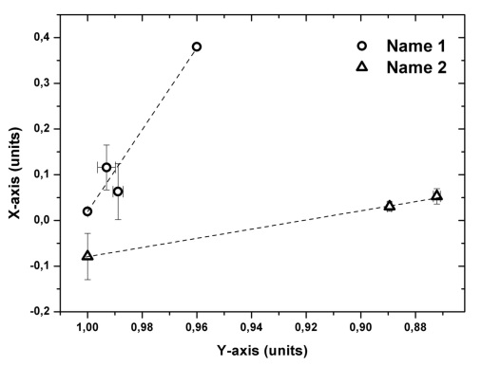
Figure 1. Figure name

The abstracts should be uploaded in the ABSTRACTS section of the conference site (www.ksups.us.edu.pl). Full papers and extended abstracts are invited in all areas related to: synchrotron and alternative radiation sources, beamline instrumentation, X-ray diffraction, X-ray absorption, fluorescence and photoelectron spectroscopies, magnetic dichroism, synchrotron radiation in physics, chemistry, crystallography, materials science and life sciences.

Acknowledgments: This work was supported by ...

___________________________________________________
- M. Svandrlik, F. Parmigiani, Nat. Photonics 8 (2014) 82.
- S. V. Krivovichev, Angew. Chem. 53 (2014) 654.
- P. Murck, New age of synchrotron studies (Sun Editors, Honolulu 1891)

